##### ASTA project – Short Phase Report

# Application Description:

The advanced speed test application (from now on – ASTA) is a client application that allows the user to test the network connection with advanced options / parameters and retrieve results for later analysis.   
This application is aimed to an experienced users with knowledge on communication protocols.  
It will be able to supply special information about the connection and data traffic that is being transferred between the application and the chosen server.

# Development on this phase:

* Debug logger – as we spoke, I decided to implement a logger mechanism in the application

I decided to use some external library with android logger.

The logger is able to write a message to a file that will be saved in device file system.

In order for the logger to get the message I used android Broadcast mechanism – with this mechanism, I am able to send a message from each activity in the application to the logger receiver and the receiver writes the message to device file.

I used an HTML file for the log, in order to write different messages in different colors easily.

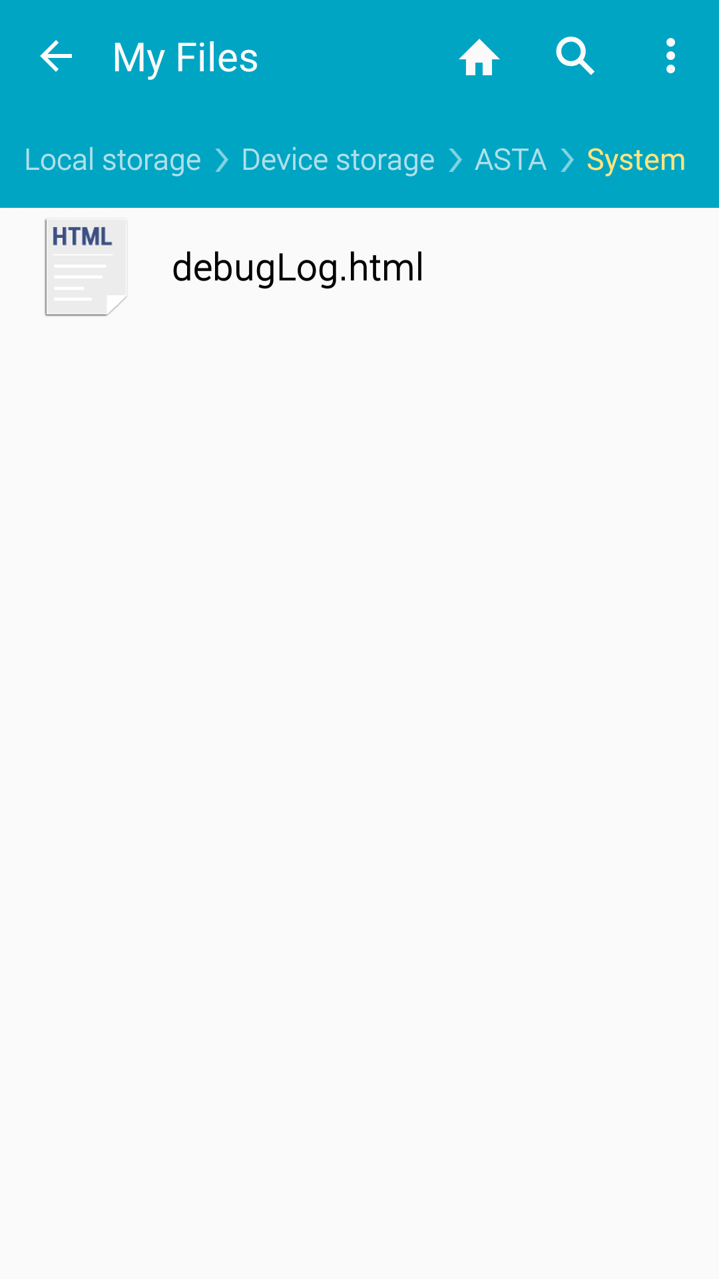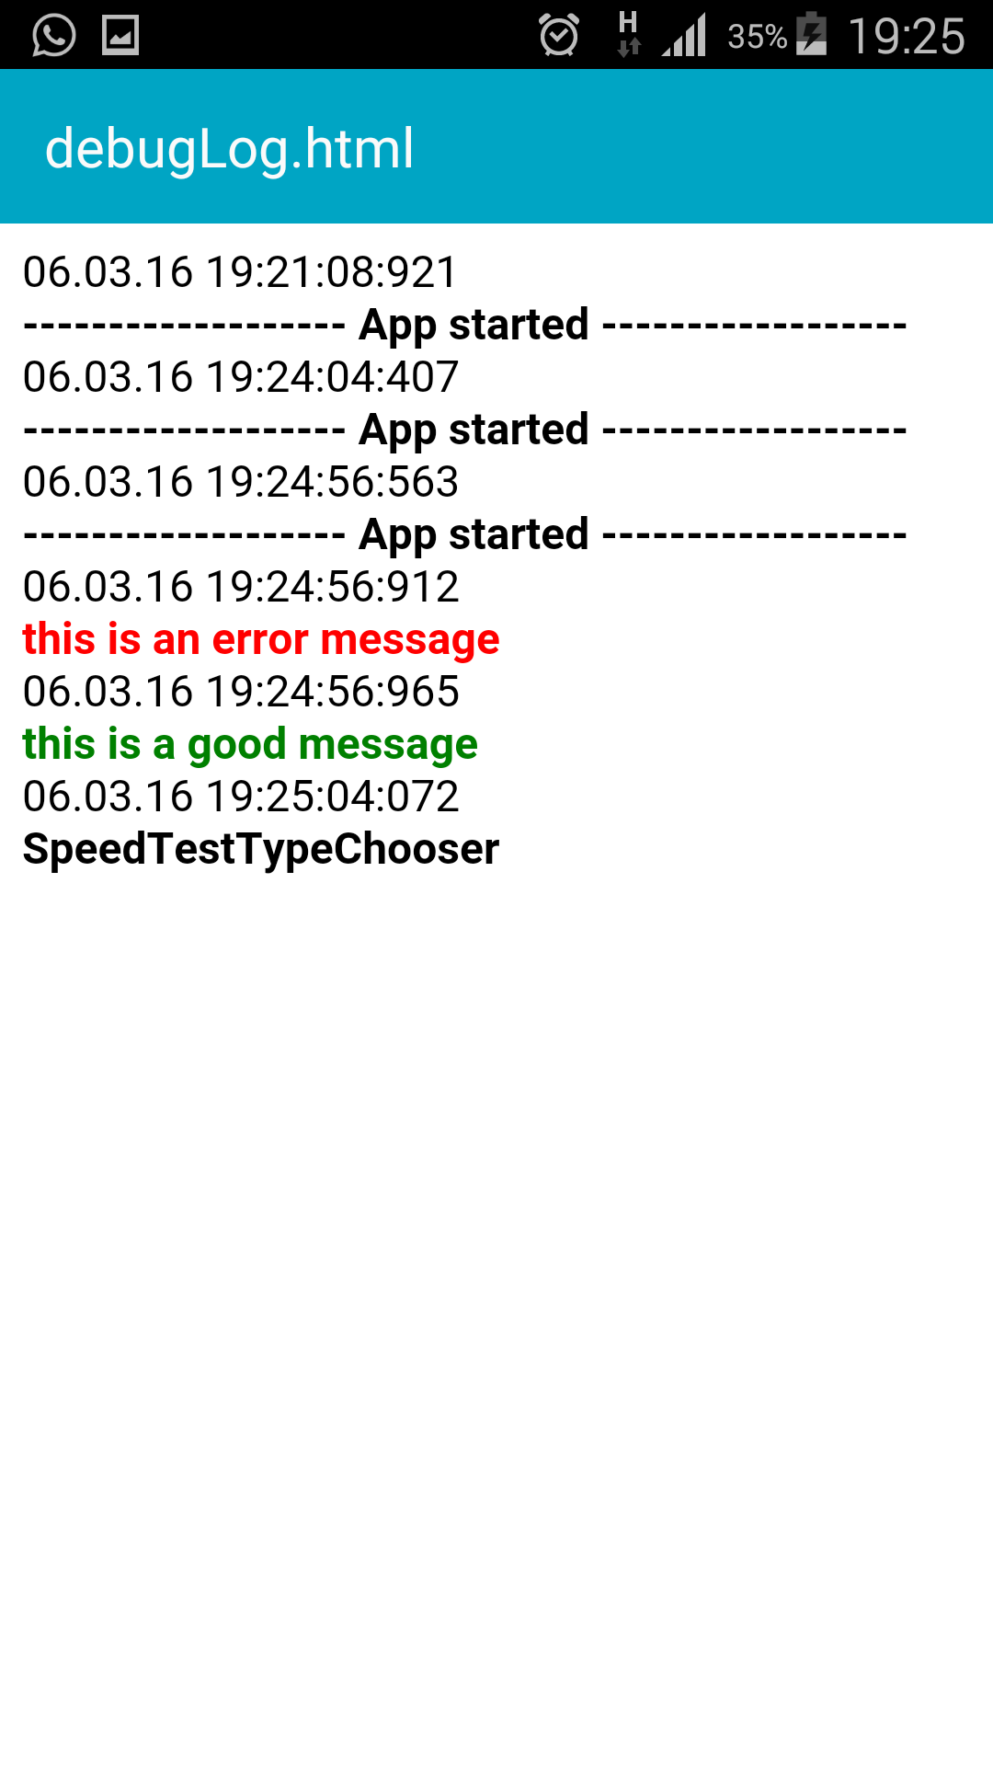

* Application structure: I implemented some of application screens:  
  I used ListActivity class in android in order to implement the menu’s.

